Hello everyone,

I know most of you have had your students keep reading logs and that is fantastic! I found an incredible program, Biblionasium. It is super easy for teachers, students, and me!

I created a challenge for every class. All you and students must do is to click on the Cobb Digital Library Icon located on your desktop.

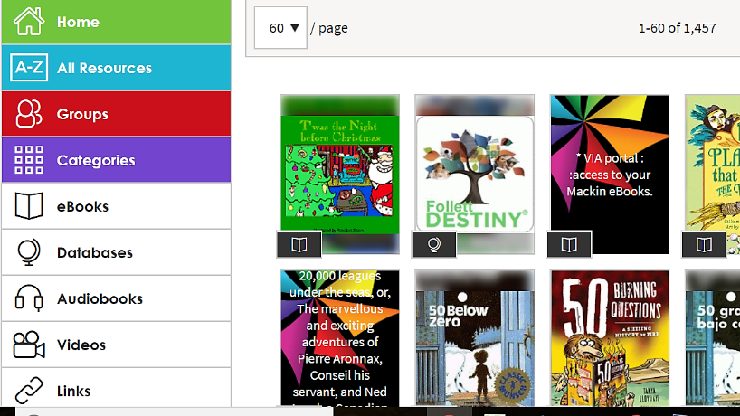

It will open like this.
Click on Databases

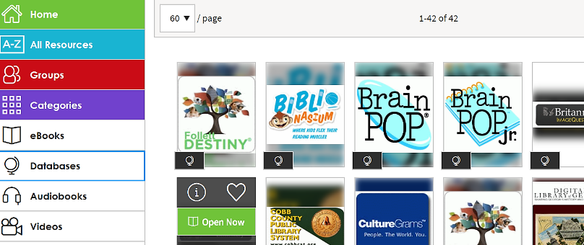
It will open like this:
Click on the second
database, Biblionasium

Then click “Login with Destiny” found on the top right of the screen.

Use the same login as you do to login to any computer at school.
I am super excited as I know you and the students will be too once you’ve had an opportunity to see everything this app can do to promote literacy and create an excitement for reading. The students will love it and will probably read more just to put their books on the shelve and log their time.

I have set up challenges specific to every grade level and every student & class. Once you login you can monitor their progress, run reports, and a lot more.

Below are two very good (and Short) videos links that will walk you and students through Biblionasium step-by-step.

This is for the students:
https://www.youtube.com/watch?v=jIIzjF2tGpw

These are videos for the you:

https://www.youtube.com/watch?v=MXFjsuQJBKI

https://www.youtube.com/watch?v=OBIUegbVvas

I promise this is an easy way to create challenges, collect important data, and monitor student progress.

If you have questions do not hesitate to come to me ~

DeLinda Jiles

